Diego Viñals Lage

FUNDAMENTOS DE LA PROGRAMACION CON RASPBERRY PI

PRACTICE 1

Tabla de contenido

First Part 2

Led 2

Led with variable brightness 3

Button 4

Button Controlled LED 5

Reaction Game 6

Second Part 8

Third Part 8

# First Part

## Led

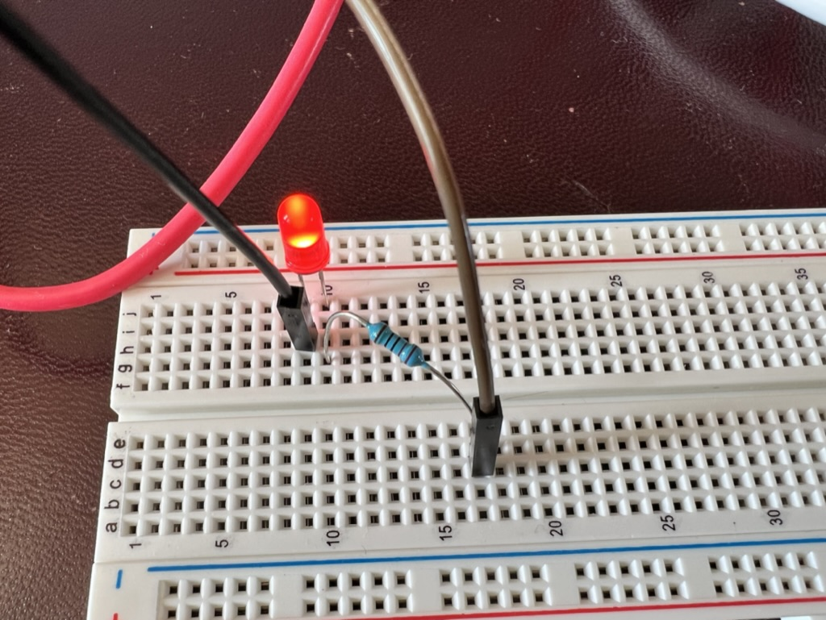

I connected a Led with a resistor and programmed in python what the LED should do. It lights up, waits one second, and then it turns off and waits another second. This goes on and on until manually stopped.

Code:

From gpiozero import LED

From time import sleep

Red = LED(17) // it is connected to GPIO 17

While True:

Red.on()

Sleep(1)

Red.off()

Sleep(1)

## Led with variable brightness

It is the same as LED, but this time the user controls de brightness of the LED.

Where is a picture of the LED with 50% brightness.

We can see comparing it to the other picture that the LED is not at full brightness.

Code:

From gpiozero import PWMLED

From time import sleep

Red = PWMLED (17) // it is connected to GPIO 17

While True:

Red.value = 0

Sleep(1)

Red.value = 0.5 // picture

Sleep(1)

Red.value = 1

Sleep(1)

## Button

We connected a button, when pressed a message is shown on screen: “Button is pressed”

Code:

From gpiozero import Button

Button = Button(2) // connected to pin Nº2

While True:

If button.is_pressed:

Print(“Button is pressed”)

Else:

Print(“Button Not pressed”)

## Button Controlled LED

We connected a button and a LED, when the button is not pressed, the LED is turn off, when you press the button, it lights up.

Where is a picture when the button is not pressed

Where is a picture when you press the Button.

Code:

From gpiozero import Button, LED

From signal import pause

Button = Button(2) // connected to pin Nº2

Red = LED(17)

Button.when_pressed = red.on

Button.when_released = red.off

Pause()

## Reaction Game

In this example, the Led is going to turn on at a random time, and the first person who presses his button wins. It will show on screen the player who wins.

Code:

From gpiozero import Button, LED

From signal import pause

import random

led = LED(17)

player 1= Button(2)

player 2 = Button(3)

time = random.uniform(5,10)

sleep(time)

led.on()

while True:

if player1.is pressed:

print ("Player 1 wins!")

break

if player 2.is pressed:

print ("Player 2 wins!")

break

led.off()

# Second Part

We can do a proximity sensor, and when the distance is less than one meter, the LED tuns on, to let us know we reached the distance. I don’t have a distance sensor right now so I can’t reproduce this example.

Another example that we can do, is a a traffic light, with 3 LEDs and 1 button. We turn on the Green Led, and each time we press the button, this led turns off and another led turns on, the yellow one. If we press another time, this one turns off and the red one turn on.

# Third Part

In this part, I am going to do an alarm system. We are going to need, the camera module, the distance sensor, a led, and a speaker.

We are going to connect all these things, and programmed it so, when the alarm is activated, if it detects some motion with the distance sensor, it turns the speaker to make a noise, so that you know that the alarm has been triggered.

When the alarm is triggered, the camera module should take a picture and send it to you. This picture is going to take your hall entrance to your house, and the LED id going to turn red.

The pseudocode is going to be more like this.

The alarm is activated,

While true:

If distance_sensor is more that 3 meters, then

Led off

Camera off

Speaker off

If distance_sensor is less that 3 meters,

Take picture

Send it to email

Speaker at 100%

Led on

Enter code:

If code = usercode

Then

Led off

Camera off

Speaker off